**Github Installation and Set Up**

**Steps for Installation:**

1. Install [GitHub Preview](Installation/Git-1.7.6-preview20110708.exe) .
2. Install [Git Extensions for windows](Installation/GitExtensions244SetupComplete.msi).
3. Create New Github Remote account on <https://github.com>

**Steps for Configuring Github with Remote:**

**Step 1:**   
When you run Get Extensions for first time, it comes with settings page with error:

[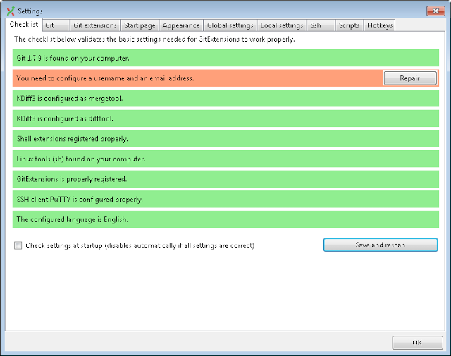](http://2.bp.blogspot.com/-Lu-c24q2x0w/T3FbUc-Q3GI/AAAAAAAAOV4/06XmxDGZT4A/s1600/2012-03-27+08h11_43.png)

Just click "Repair" and fill missing details

[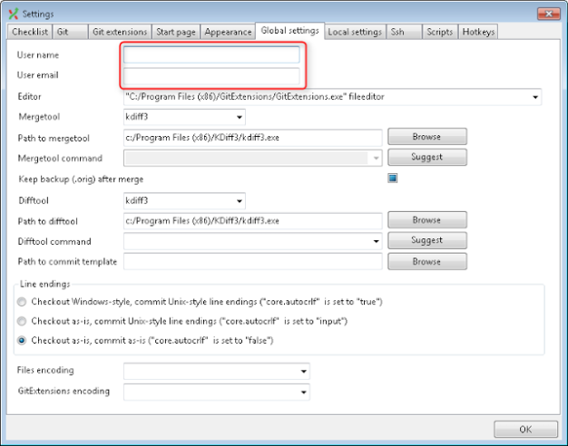](http://2.bp.blogspot.com/-ylYwkoE4bAM/T3Fb3LsJ0_I/AAAAAAAAOWA/dDa2rl4atdk/s1600/2012-03-27+08h11_54.png)

**Step 2: Adding SSH KEY for connecting Remote and Local Repository for Github**

Now it is time to create your SSH key. You may follow instructions from GitHub, but I want to show you my way.

Way1 for Generating SSH Key:

Open “Git Bash” and type ssh-keygen –t rsa -C "your_email@example.com"

Way2 for generating SSH Key:

When we installed Git Extensions, we selected "PuTTY" as SSH client and it resulted with helpful PuTTY utilities was installed. You may find them in ***C:\Program Files\GitExtensions\PuTTY***

[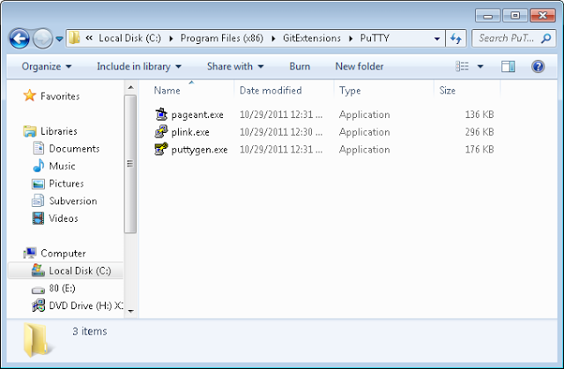](http://2.bp.blogspot.com/-72FA74hTGrg/T3FhZZ9WXBI/AAAAAAAAOWI/X6iWfv2ZR98/s1600/2012-03-27+08h41_08.png)

**pageant.exe** - PuTTY SSH authentication agent,  
**plink.exe** - PuTTY SSH client,  
**puttygen.exe** - PuTTY SSH key generator.  
Run **puttygen.exe,** click "Generate" button and move mouse over black area while progress is displayed.

[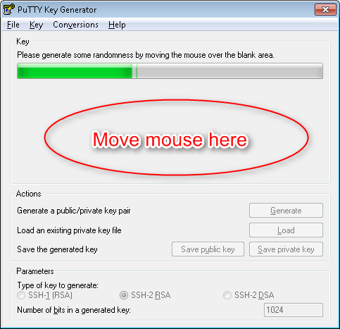](http://2.bp.blogspot.com/-4EcMBXhU4dI/T3Fj0SlMhdI/AAAAAAAAOWU/RGHgiAnZARk/s1600/2012-03-27+08h49_56.png)

This way you generated your SSH key.

[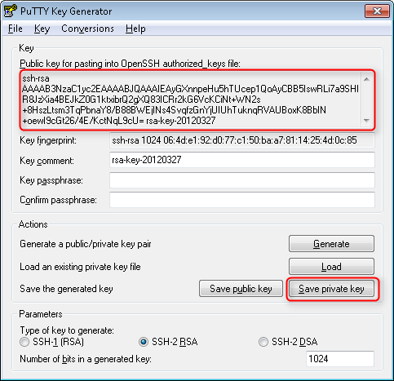](http://2.bp.blogspot.com/-dRGcf9Af_JI/T3FkAQ86Y3I/AAAAAAAAOWc/WkUVPM1uBbo/s1600/2012-03-27+08h49_31.png)

Now save private key (you may select passphrase (password) if you want). Note: you have to keep you private key in secret.  
  
Copy text from textbox above - it is your public key. This is what you put into your GitHub account. You can always get this public key by loading your private key in **puttygen**. (File > Load private key).  
  
Not it is time to come back to GitHub <https://github.com/settings/ssh>.

Click "Add SSH key", give a name for this key and copy you public key from **puttygen.** Click "Add key" -   
SSH Keys list shows your newly created key:

[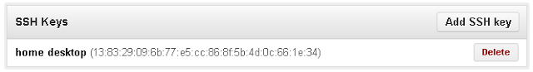](http://4.bp.blogspot.com/-viN8jUt0oYY/T3FnxNoeORI/AAAAAAAAOWw/OMlv5_DGiHU/s1600/2012-03-27+09h07_07.png)

From main page (<https://github.com/>) click "New repository", fill the form and click "Create repository"

**Step 3: Working with GitHub repository with Git Extensions**

Open Git Extensions and click "Clone repository"

Fill repository url and destination. Then click "Load SSH key".

[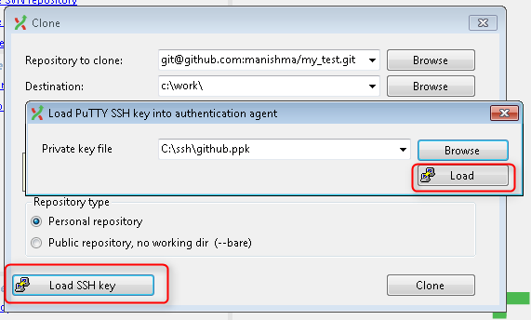](http://4.bp.blogspot.com/-0qCa5_ZgrGQ/T3F4gMScxkI/AAAAAAAAOXQ/s4UvzHS5ekk/s1600/2012-03-27+10h05_21.png)

Select you previously saved private key and click "Load". It might prompt password, if you set up one when saved the private key.

Loading SSH key required for authentication against GitHub.

Click "Clone". Git Extensions will create destination directory and initialize local git repository there.

Now go back to Git Extensions and click "Commit". You will get commit dialog:

[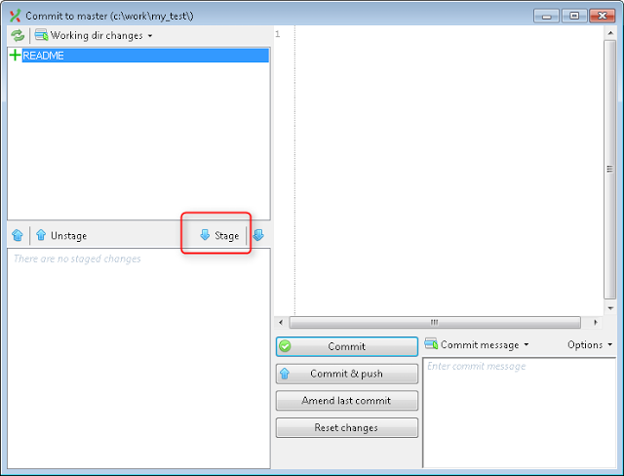](http://1.bp.blogspot.com/-xOfw7Uq0kzc/T3F-a3jtK9I/AAAAAAAAOYA/uP7-hd3mr3o/s1600/2012-03-27+10h08_12.png)

Our newly created file have no persistency in repository, Click "Stage" to "fix" it.

[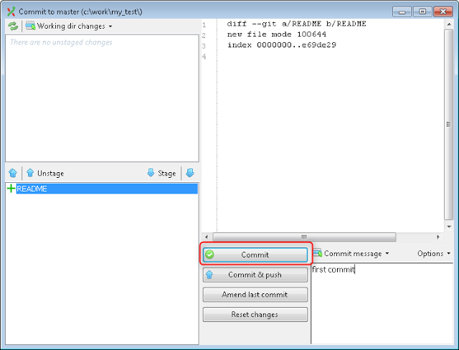](http://2.bp.blogspot.com/-wCn9jzLzItk/T3F-q4nPgHI/AAAAAAAAOYI/feFlQNsghUA/s1600/2012-03-27+10h08_34.png)

Now it is ready for commit. Put commit message and click "Commit".  
  
Git Extensions shows this first commit in our local repository (red colored label).

[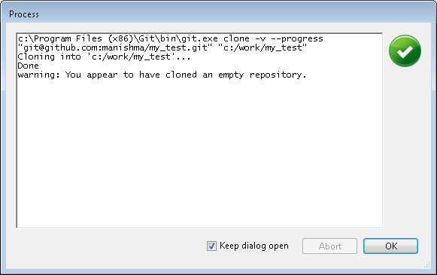](http://2.bp.blogspot.com/-2mUxZcCaoH0/T3F59s0rhdI/AAAAAAAAOXY/HaPBNx6mb54/s1600/2012-03-27+10h06_12.png)

Click "OK" - it prompts with "Open repository" dialog.

Go to menu "Commands" > "Push". It opens "Push" dialog:

[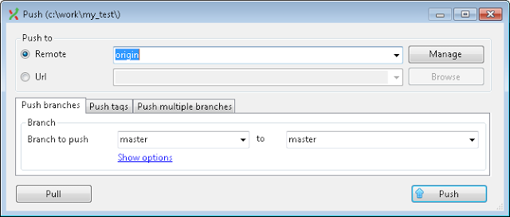](http://2.bp.blogspot.com/-L6EJzcNE6dw/T3GAmngkd6I/AAAAAAAAOYY/-q6Wu2r5eAE/s1600/2012-03-27+10h09_34.png)

Click "Push". Because there is no master branch in remote repository yet, it opens confirmation dialog:

[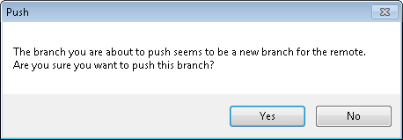](http://2.bp.blogspot.com/-wlXGrDJMyc4/T3GBHf0YkVI/AAAAAAAAOYo/DMbrvHGuy40/s1600/2012-03-27+10h09_50.png)

Click "Yes".  
  
Now Git Extensions shows your remote repository branch (green colored label)  
Since we have created master branch in GitHub repository, it's page doesn't show Git set up instructions, but all repository related information:  
All further commit with this repository are similar to first one. You make changes, stage them, commit and push.

### Cloning public repository from GitHub

If you want to clone some public repository from GitHub, you have to follow the same steps as you clone your own repository. The difference is in repository url. To obtain repository url go repository page.  
  
There is my repository page for example

[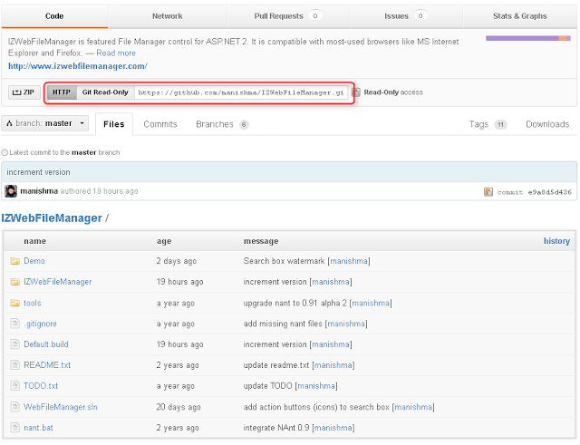](http://1.bp.blogspot.com/-rT-Ty9iW72M/T3GFuapmgdI/AAAAAAAAOZA/y0S-LEB3LGo/s1600/2012-03-27+11h15_53.png)

In case you select read only access url, you even don't need to configure SSH key. (You still need it for read-write access).

### Authentication failures and loading SSH key

When you open local repository with Git Extensions and want to update or push you changes from/to remote GitHub repository, you might fail into authentication error:

It happens if your SSH key has not been loaded yet. Don't panic, click "Load SSH key", select your SSH private key and then click "Retry".

Ref :

**Video Tutorial**

* 1 Clone - Git Extensions - <http://www.youtube.com/watch?v=TlZXSkJGKF8>
* 2 Commit changes - <http://www.youtube.com/watch?v=B8uvje6X7lo>
* 3 Push changes - <http://www.youtube.com/watch?v=JByfXdbVAiE>
* 4 Pull changes - <http://www.youtube.com/watch?v=9g8gXPsi5Ko>
* 5 Handle merge conflicts - <http://www.youtube.com/watch?v=Kmc39RvuGM8>